|  |
| --- |
| **NAVRACHANA UNIVERSITY** |
|  |
|  |
| **SCHOOL OF ENGINEERING & TECHNOLOGY** |
|  |
| **BTech-IT** |
|  |
|  |
| **PROJECT**  **RECORD**  **(Review Phase -1)** |
|  |
|  |
| **Final Year BTech-IT** |
|  |
| **SEMESTER: 7** |
|  |
|  |
| **COURSE: IN HOUSE PROJECT** |
|  |
| **COURSE CODE:** |
|  |
| **ACADEMIC YEAR: 2021-22 SEMESTER: AUTUMN** |
|  |
| **TEAM ID: 9** |
|  |
| **PROJECT NAME: Virtual Assistant** |
|  |
| **MEMBER IDs & NAMES: 18103610 – Darpan Patel**  **18103627 – Harsh Kheni** |
|  |

**PHASE – 1 BRAINSTORMING AND REQUIREMENT ELICITATION**

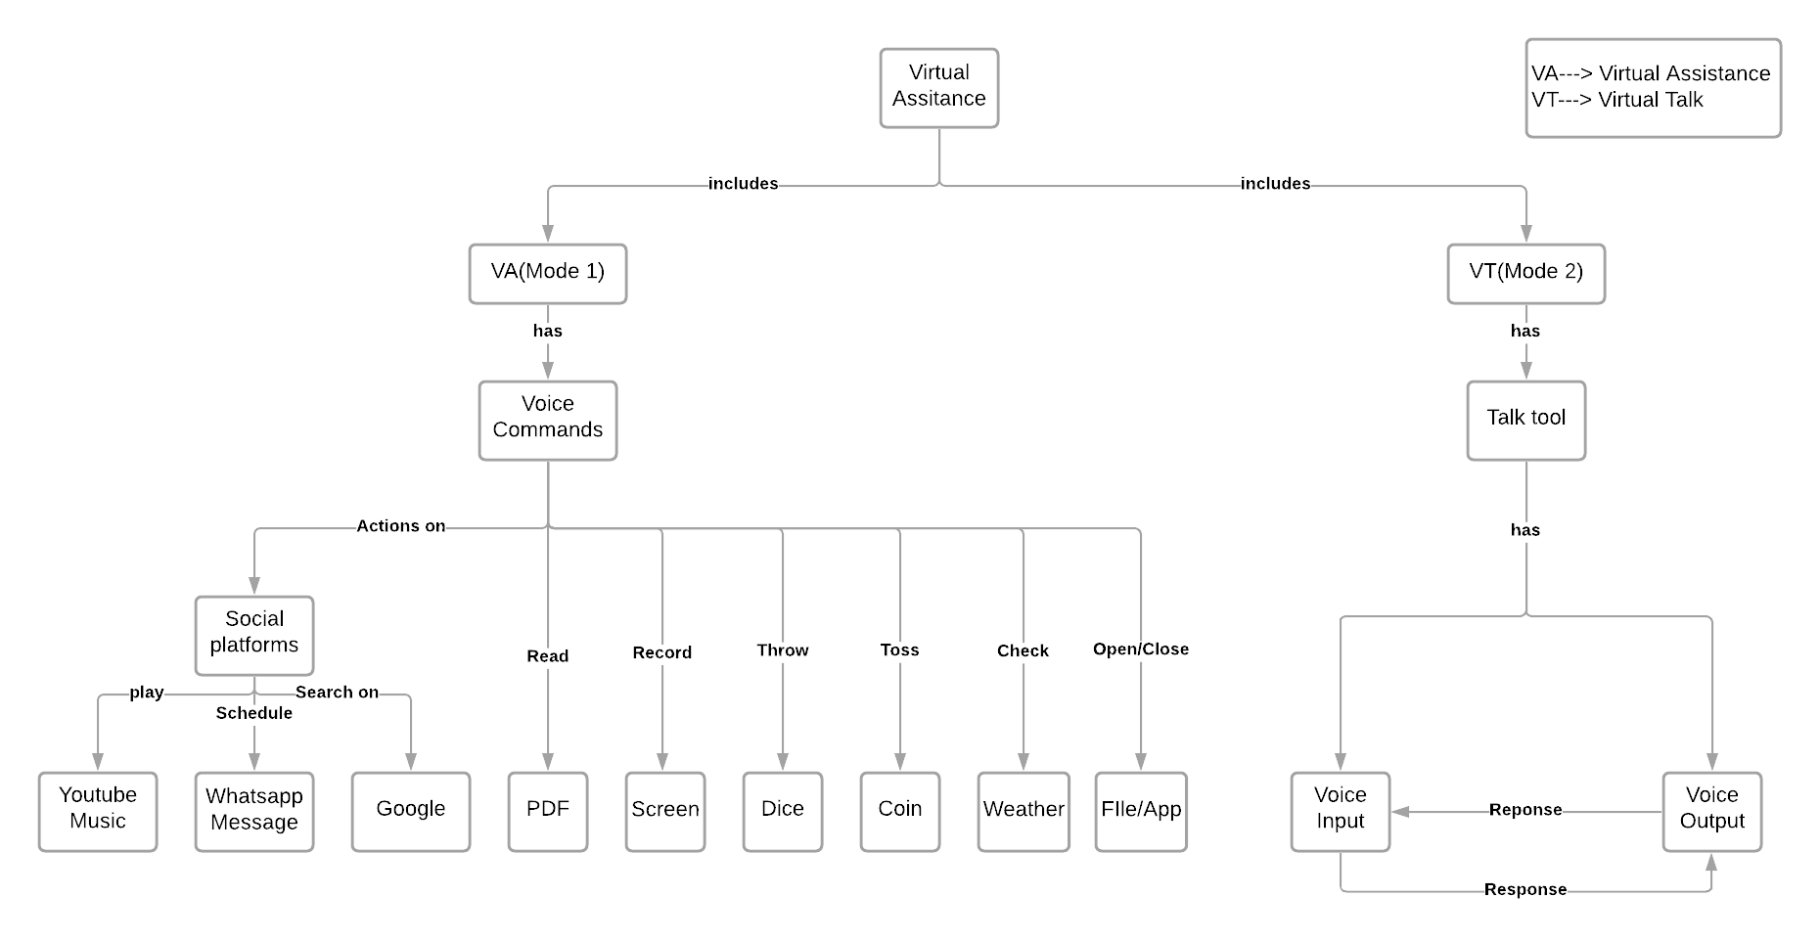**TASK 1: Concept Map**

**Description:**

This virtual assistant will be working on two modes:

1. Virtual Assistant
2. Virtual Talking

Virtual Assistant

* Consist of voice commands where user just need to say what he/she wants to do and so it takes number of inputs through this voice commands like play a music, schedule a WhatsApp message, Search on google, read a pdf, record screen, throw a dice, toss a coin, check whether, open/close a file/app, etc.

Virtual Talking

* Consist of voice input as well as voice output which will work on response model as it will be a normal conversation not actually between 2 humans but one will be human and another will be the system itself .

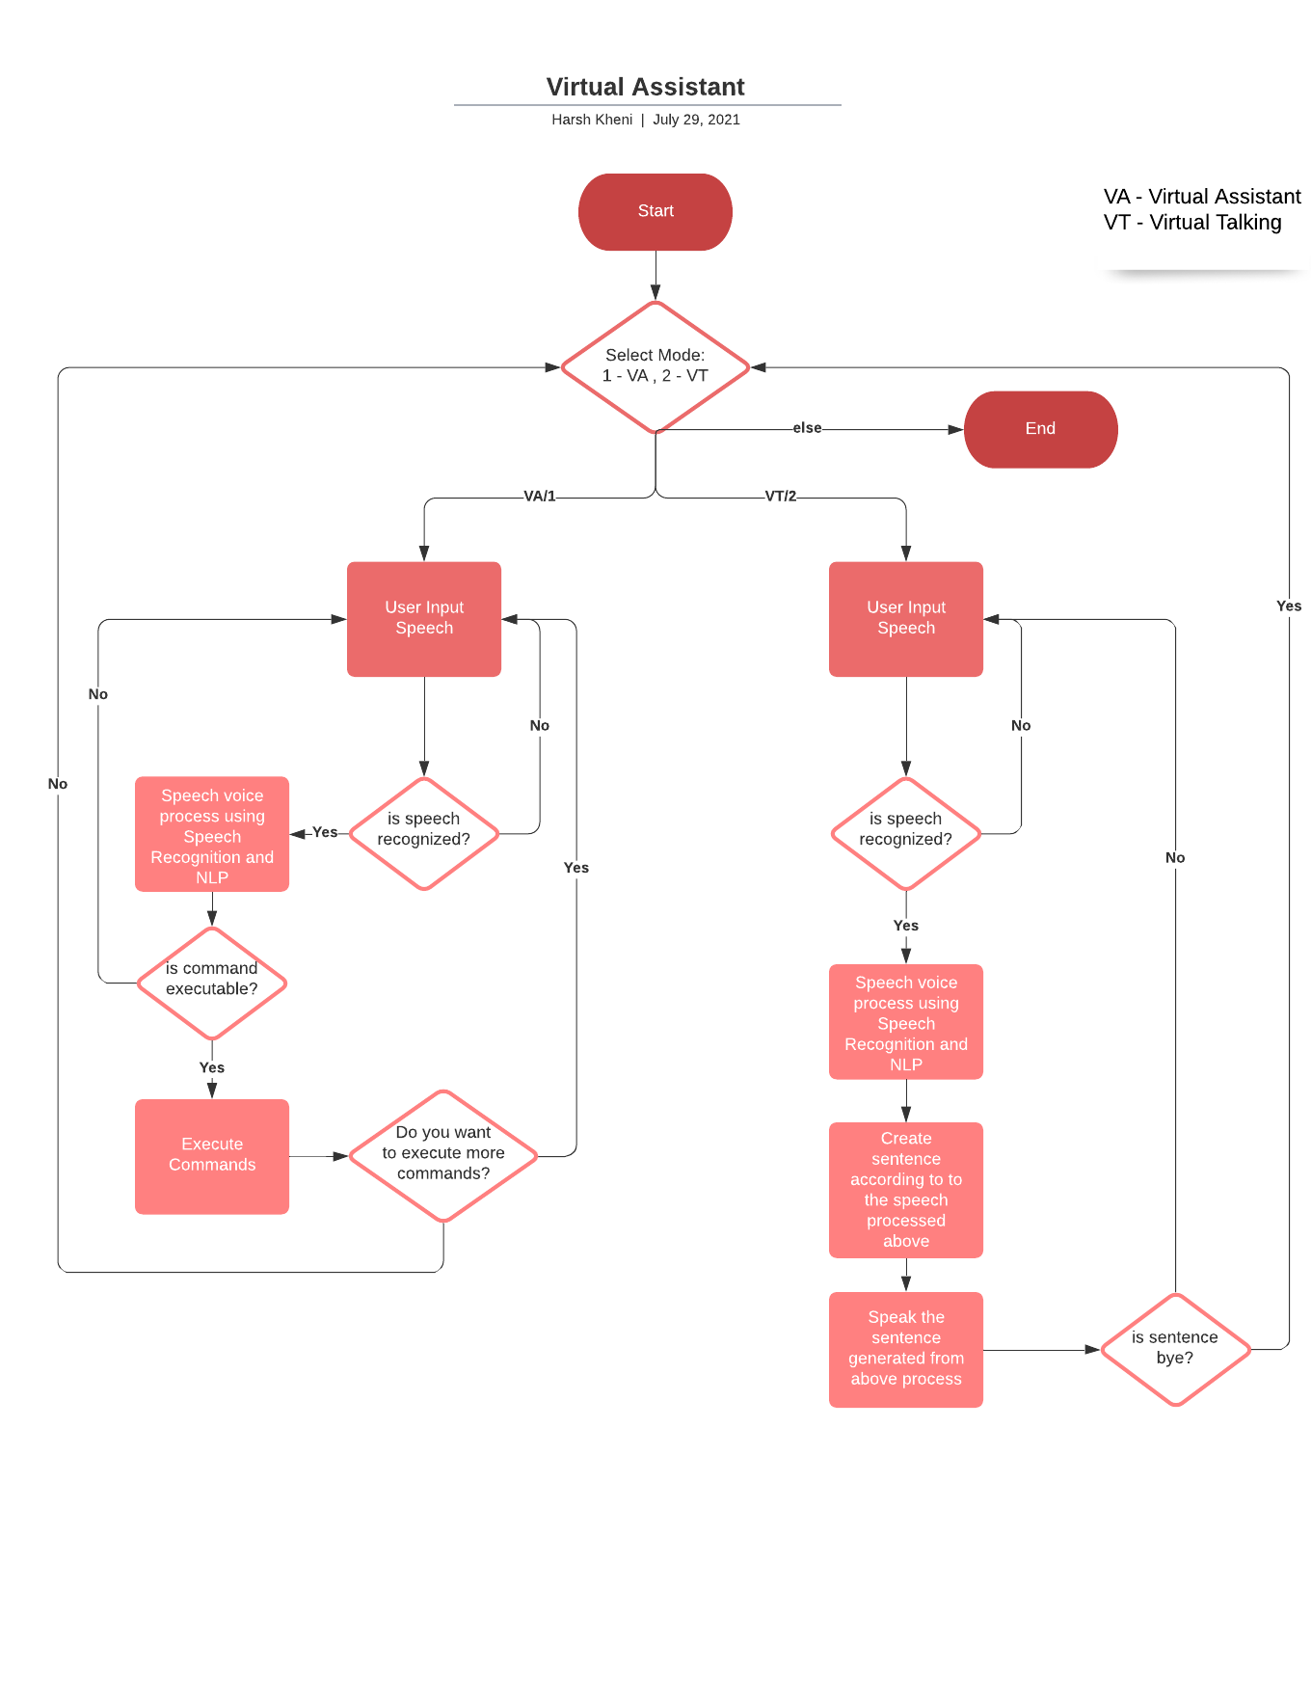**TASK 2: Flowchart**

**Description:**

This virtual assistant will be working on two modes:

1. Virtual Assistant
2. Virtual Talking

If user select virtual assistant, then user system will wait for the user to provide an input in form of voice and if the voice is recognized then it will be sent for processing. It will be processed with the help of Speech recognition and NLP. It will check whether the command recognized is executable our not. If it is executable then it executes the command and if then it will ask to provide proper command.

After executing the command system will ask the user to execute more commands and if users says yes then if would again follow the above process and if no then if would again asked to select mode.

If no mode is selected then it would exit.

**TASK 3:**

Describe the different requirements for the system.

Building Requirements:

-Windows/Linux with Python installed

-Internet Connectivity

-Speech Dataset (Construct)

-Microsoft Azure ML Studio

-Speech recognition: to convert user speech to text

-Natural language processing: to understand the transcribed text, take an appropriate action and formulate a response.

Using Requirements:

-Windows/Linux with Python Installed with Python packages

-Internet Connectivity

-Min 2GB of RAM

-Recommended 4GB of RAM

**Note:** These tasks are not exhaustive, if you want to suggest some changes or would like to ask a question then you can do so.

**FUTURE SCOPE**

**(You can include your project’s feasibility study here)**

**Actionable Items:**

1. This system is a base part of a big system ahead as adding AR to this system will enhance the beauty of this system.
2. This system requires python to be installed with other packages then only it will be working and so further it can be made like an application in .exe format and which can be also installed into the systems.
3. The Automation side can also be updated with ML algorithms further to provide a greater number of functionalities with efficient and reliable manner.
4. This system works in desktop-based system with python installed to further this system can be enhance to work on different operating systems as well like in mobile, tab etc.